EVIDENCE INDEX – BSI.IT.31.C19.05 Server Patch Testing (Solaris / Linux)
Each screenshot in this document has an Evidence Ref (SL-01 to SL-12) in a blue box directly above it. The same Ref appears in the workbook "BSI.IT.31.C19.05_Server Population and Snow Ticket Testing.xlsx", sheet "Testing -Results", column AB, on the row of the server it supports. To find a server: look up its Ref below, or press Ctrl+F and search the Ref (e.g. "SL-08") or the server name.
Ref | Server / OS | Workbook sample month & row (Testing -Results) | Change ticket | What the screenshot shows
SL-01 | miaecodir  Linux (RHEL 8) | May 2026 - row 33 | CHG002971836 | systemctl status shows host miaecodir running; uname -a shows patched kernel 4.18.0-553.146.1.el8_10 (built Jul 19 2026). Screenshot taken 08/05-08/07/2026.
SL-02 | miaecofs  Linux (RHEL 8) | May 2026 - row 34 | CHG002971836 | systemctl status shows host miaecofs running since 2026-08-05; uname -a shows patched kernel 4.18.0-553.146.1.el8_10.
SL-03 | miaecowas  Linux (RHEL 8) | May 2026 - row 35 | CHG002971836 | systemctl status shows host miaecowas.mia.usa.sinvest running since 2026-08-05; uname -a shows patched kernel 4.18.0-553.146.1.el8_10.
SL-04 | miaecoweb  Linux (RHEL 8) | May 2026 - row 36 | CHG002971836 | systemctl status shows host miaecoweb running since 2026-08-05; uname -a shows patched kernel 4.18.0-553.146.1.el8_10.
SL-05 | miadcpositdata  Linux (RHEL 8) | May 2026 - row 37 | CHG002971836 | systemctl status shows host miadcpositdata running since 2026-08-13; uname -a shows patched kernel 4.18.0-553.146.1.el8_10.
SL-06 | miadcpositwork01  Linux (RHEL 8) | May 2026 - row 38 | CHG002971836 | systemctl status shows host miadcpositwork01 running since 2026-08-13; uname -a shows patched kernel 4.18.0-553.146.1.el8_10.
SL-07 | miadcpositwork02  Linux (RHEL 8) | Not a sampled server (supporting only) | CHG003169143 | systemctl status shows host miadcpositwork02 running since 2026-08-13; uname -a shows patched kernel 4.18.0-553.146.1.el8_10.
SL-08 | miasxprd-mgt (global zone)  Solaris 11.4 | Feb 2026 - row 23; May 2026 - row 30 | Feb: CHG002761130 / May: CHG002971776 | beadm list shows boot environments Sol1Q26_BE (created 2026-01-27), Sol2Q26_BE (created 2026-04-24) and active SolJun26_BE (NR); pkg info entire shows Oracle Solaris 11.4.93.221.2, Last Update Time June 22, 2026.
SL-09 | miasx1 (non-global zone)  Solaris 11.4 | Feb 2026 - row 26; May 2026 - row 31 | Feb: CHG002761130 / May: CHG002971776 | beadm list shows Sol1Q26_BE, Sol2Q26_BE and active SolJun26_BE (NR); pkg info entire shows 11.4.93.221.2, Last Update Time Mon Jun 22 14:58:33 2026.
SL-10 | miasx3 (non-global zone)  Solaris 11.4 | Feb 2026 - row 25; May 2026 - row 32 | Feb: CHG002761130 / May: CHG002971776 | beadm list shows Sol1Q26_BE, Sol2Q26_BE and active SolJun26_BE (NR); pkg info entire shows 11.4.93.221.2, Last Update Time June 22, 2026 2:56:36 PM.
SL-11 | mia-dc-rep, mia-dc-rep8, mia-dc-rep9  Linux (RHEL 7/8/9) | Supporting only - explains the RHEL 8 kernel version seen in SL-01 to SL-07 | CHG003169143 | Before/after uname -a for RHEL 7 (3.10.0-1160.149.1 to 1160.156.1), RHEL 8 (4.18.0-553.129.1 to 553.146.1) and RHEL 9 (5.14.0-687.13.1 to 687.29.1).
SL-12 | ashsxdr-mgt (global zone) - covers ashsx1 and ashsx2  Solaris 11.4 | Feb 2026 - rows 24, 27, 28 | CHG002761130 | Teams message from Susan Menig with a beadm list from ashsxdr-mgt showing Sol1Q26_BE (created 2026-01-27) active (NR). She states ashsx1 and ashsx2 are non-global zones and must run the same boot environment as ashsxdr-mgt.
Grey rows are supporting screenshots for servers that are not in the test sample.

Redhat OS Updates – RHEL 8 kernel version 4.18.0-553.146.1

Patching 08/05/2026:

1.miaecodir:

Evidence Ref SL-01 | Server: miaecodir | Linux (RHEL 8)
Workbook: Testing -Results – May 2026 - row 33 | Change: CHG002971836
Shows: systemctl status shows host miaecodir running; uname -a shows patched kernel 4.18.0-553.146.1.el8_10 (built Jul 19 2026). Screenshot taken 08/05-08/07/2026.
Note: Kernel 4.18.0-553.146.1 is the August 2026 RHEL release (see SL-11, CHG003169143); screenshot shows current patched state, taken after the May 2026 change.
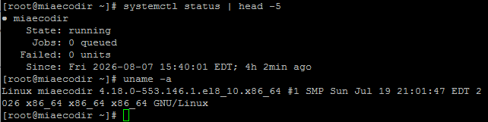

2.miaecofs:

Evidence Ref SL-02 | Server: miaecofs | Linux (RHEL 8)
Workbook: Testing -Results – May 2026 - row 34 | Change: CHG002971836
Shows: systemctl status shows host miaecofs running since 2026-08-05; uname -a shows patched kernel 4.18.0-553.146.1.el8_10.
Note: Same as SL-01: August 2026 kernel, taken after the May 2026 change.
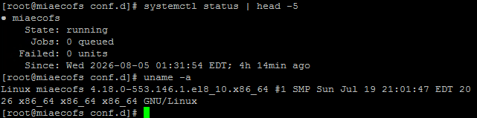

3.miaecowas:

Evidence Ref SL-03 | Server: miaecowas | Linux (RHEL 8)
Workbook: Testing -Results – May 2026 - row 35 | Change: CHG002971836
Shows: systemctl status shows host miaecowas.mia.usa.sinvest running since 2026-08-05; uname -a shows patched kernel 4.18.0-553.146.1.el8_10.
Note: Same as SL-01: August 2026 kernel, taken after the May 2026 change.
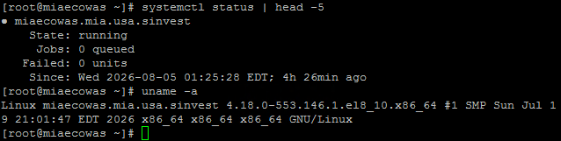

4.miaecoweb:

Evidence Ref SL-04 | Server: miaecoweb | Linux (RHEL 8)
Workbook: Testing -Results – May 2026 - row 36 | Change: CHG002971836
Shows: systemctl status shows host miaecoweb running since 2026-08-05; uname -a shows patched kernel 4.18.0-553.146.1.el8_10.
Note: Same as SL-01: August 2026 kernel, taken after the May 2026 change.
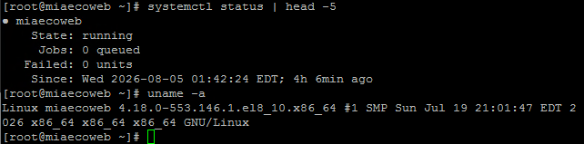
Patching 08/13/2026:

5.miadcpositdata:

Evidence Ref SL-05 | Server: miadcpositdata | Linux (RHEL 8)
Workbook: Testing -Results – May 2026 - row 37 | Change: CHG002971836
Shows: systemctl status shows host miadcpositdata running since 2026-08-13; uname -a shows patched kernel 4.18.0-553.146.1.el8_10.
Note: Same as SL-01: August 2026 kernel, taken after the May 2026 change.
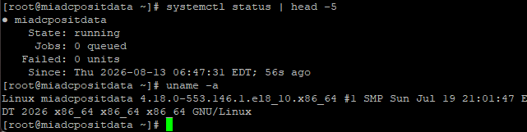

6.miadcpositwork01:

Evidence Ref SL-06 | Server: miadcpositwork01 | Linux (RHEL 8)
Workbook: Testing -Results – May 2026 - row 38 | Change: CHG002971836
Shows: systemctl status shows host miadcpositwork01 running since 2026-08-13; uname -a shows patched kernel 4.18.0-553.146.1.el8_10.
Note: Same as SL-01: August 2026 kernel, taken after the May 2026 change.
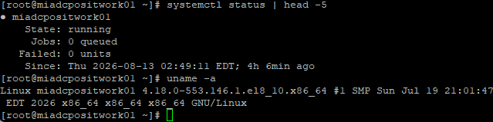

7.miadcpositwork02:

Evidence Ref SL-07 | Server: miadcpositwork02 | Linux (RHEL 8)
Workbook: Testing -Results – Not a sampled server (supporting only) | Change: CHG003169143
Shows: systemctl status shows host miadcpositwork02 running since 2026-08-13; uname -a shows patched kernel 4.18.0-553.146.1.el8_10.
Note: Not in the sample; no row in the workbook.
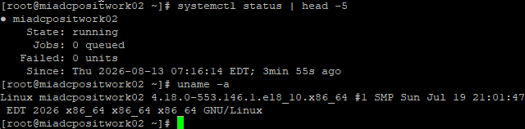

8.Solaris OS updates – 11.4.93.221.2:
miasxprd-mgt (global zone):
Evidence Ref SL-08 | Server: miasxprd-mgt (global zone) | Solaris 11.4
Workbook: Testing -Results – Feb 2026 - row 23; May 2026 - row 30 | Change: Feb: CHG002761130 / May: CHG002971776
Shows: beadm list shows boot environments Sol1Q26_BE (created 2026-01-27), Sol2Q26_BE (created 2026-04-24) and active SolJun26_BE (NR); pkg info entire shows Oracle Solaris 11.4.93.221.2, Last Update Time June 22, 2026.
Note: Active boot environment is the June 2026 one; the 1Q26 and 2Q26 boot environments tie to the Feb and May changes but the screenshot was taken after both.
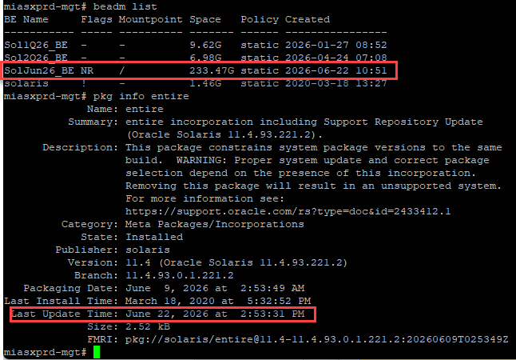
9.miasx1 (non-global zone):
Evidence Ref SL-09 | Server: miasx1 (non-global zone) | Solaris 11.4
Workbook: Testing -Results – Feb 2026 - row 26; May 2026 - row 31 | Change: Feb: CHG002761130 / May: CHG002971776
Shows: beadm list shows Sol1Q26_BE, Sol2Q26_BE and active SolJun26_BE (NR); pkg info entire shows 11.4.93.221.2, Last Update Time Mon Jun 22 14:58:33 2026.
Note: Same as SL-08: taken after the Feb and May changes.
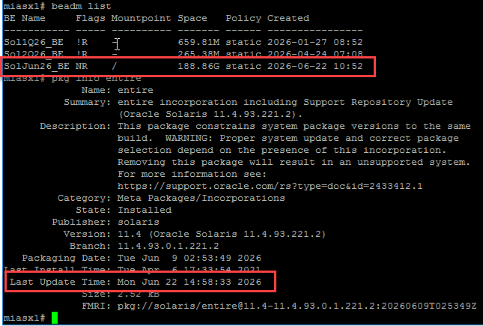
10.miasx3 (non-global zone):
Evidence Ref SL-10 | Server: miasx3 (non-global zone) | Solaris 11.4
Workbook: Testing -Results – Feb 2026 - row 25; May 2026 - row 32 | Change: Feb: CHG002761130 / May: CHG002971776
Shows: beadm list shows Sol1Q26_BE, Sol2Q26_BE and active SolJun26_BE (NR); pkg info entire shows 11.4.93.221.2, Last Update Time June 22, 2026 2:56:36 PM.
Note: Same as SL-08: taken after the Feb and May changes.
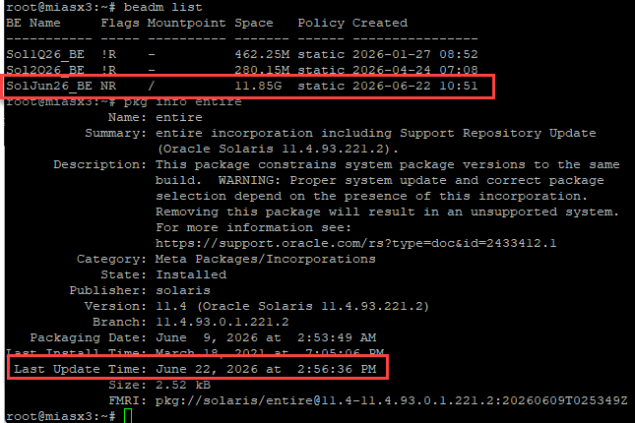

11. CHG003169143 Aug2026 RHEL Update
The version of the OS (uname -a output) confirms the patch – it shows the version that was indicated on CHG003169143 Aug2026 RHEL Update Evidence for this August patching cycle. I include this information in the CHG evidence.

Evidence Ref SL-11 | Server: mia-dc-rep, mia-dc-rep8, mia-dc-rep9 | Linux (RHEL 7/8/9)
Workbook: Testing -Results – Supporting only - explains the RHEL 8 kernel version seen in SL-01 to SL-07 | Change: CHG003169143
Shows: Before/after uname -a for RHEL 7 (3.10.0-1160.149.1 to 1160.156.1), RHEL 8 (4.18.0-553.129.1 to 553.146.1) and RHEL 9 (5.14.0-687.13.1 to 687.29.1).
Note: These hosts are not in the sample. Use this page to confirm 4.18.0-553.146.1 is the patched RHEL 8 kernel.
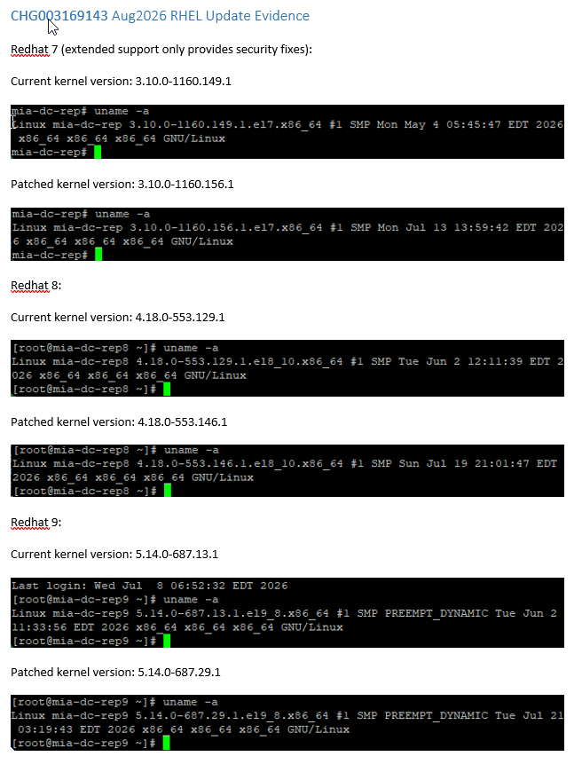

Server for the Month Feb-26:
This Sever ashsxdr-mgt covers the following:
ashsx2
ashsx1

Evidence Ref SL-12 | Server: ashsxdr-mgt (global zone) - covers ashsx1 and ashsx2 | Solaris 11.4
Workbook: Testing -Results – Feb 2026 - rows 24, 27, 28 | Change: CHG002761130
Shows: Teams message from Susan Menig with a beadm list from ashsxdr-mgt showing Sol1Q26_BE (created 2026-01-27) active (NR). She states ashsx1 and ashsx2 are non-global zones and must run the same boot environment as ashsxdr-mgt.
Note: Screenshot is from the next cycle, and there is no direct screenshot of ashsx1 or ashsx2. Coverage of ashsx1/ashsx2 relies on the global-zone explanation.
